International Cybersecurity and Digital Forensics Academy (ICDFA)
CIP-B103: Network Forensics Fundamentals
LAB 4: SMTP Email Traffic Forensics
Three-Week Delivery Block 2/3 | 25-26 July 2026
Prepared by: Aminu Idris, AMCPN | Founder, ICDFA
Important Pre-Lab Instruction
Read the matching lecture slide deck before executing the practical. Work only inside the ICDFA-approved lab or your own isolated virtual environment. Record every command, observation and screenshot as contemporaneous evidence.
Course Code | CIP-B103
Course Title | Network Forensics Fundamentals
Lab Number | Lab 4
Lab Title | SMTP Email Traffic Forensics
Student Name | Fuseini Imoru Kantuogaa
Student ID | 17291
Instructors Name | Dr. Sarah James
Delivery Block | 2/3 of 3
Scheduled Dates | 25-26 July 2026
Estimated Duration | 3-4 hours practical work plus report writing
Mode | Individual practical lab in an authorized virtual environment
Required Evidence | smtp.pcap supplied sample capture

1. Source Materials and Slide Alignment
- Email Traffic Forensics: SMTP purpose, ports 25/587/465, plaintext commands, STARTTLS/SMTPS distinctions, Base64 encoding, stream reassembly and email-content analysis.
- The slide practical uses smtp.pcap containing Microsoft Outlook traffic and requires timestamps, client, content, ports, IP addresses and MAC addresses.
- The exercise treats credentials as sensitive evidence and requires protected reporting.
Reading Requirement Before Lab Execution
The lab deliberately follows the sequence, terminology and core exercises presented in the uploaded CIP-B103 slides. Commands have been corrected where needed for Linux syntax and forensic repeatability.

2. Lab Scenario
A historical SMTP packet capture has been supplied for analysis. You must determine when the email exchange occurred, identify the client and server, reconstruct SMTP commands and response codes, decode relevant Base64 authentication fields, recover the message content, and document the network path without exposing sensitive data unnecessarily.

3. Learning Outcomes
- Explain the role of SMTP and distinguish plaintext SMTP, STARTTLS and implicit TLS.
- Identify SMTP commands, server response codes and authentication exchanges.
- Reassemble an SMTP TCP stream and reconstruct message headers and body.
- Decode Base64 values in a controlled offline manner.
- Extract timestamps, client software, IP addresses, ports and MAC addresses.
- Assess evidential limitations when encryption is used or capture is incomplete.

4. Legal, Ethical and Safety Rules
- Use only systems, packet captures and networks for which you have explicit authorization.
- Keep the lab isolated from production, campus, office and public networks. Use NAT or host-only virtual networking as instructed.
- Do not collect, disclose or reuse real credentials, personal messages or confidential traffic.
- Preserve original capture files. Perform analysis on verified working copies and record SHA-256 hashes.
- Stop any traffic-generation or interception process immediately after the required evidence is captured.
- Restore firewall, ARP, forwarding and network settings before closing the lab.
- Treat any recovered username, password or message content as confidential assessment evidence. Mask sensitive values in screenshots unless the instructor explicitly requires the full value.

5. Required Tools and Environment
Item | Recommended Tool | Purpose
Operating system | Kali Linux or Ubuntu VM | Analyze the capture.
Packet tools | Wireshark and tshark | Filter and reconstruct SMTP streams.
Decoder | Python 3 base64 module | Decode Base64 strings offline.
Hashing | sha256sum | Preserve evidence integrity.
Evidence | smtp.pcap | Historical training traffic.
Text editor | Any local editor | Document recovered message safely.

6. Lab Folder Structure and Evidence Preparation
mkdir -p ~/CIP-B103-Lab4/{evidence,working,exported,reports,screenshots,scripts}
cd ~/CIP-B103-Lab4
pwd
find . -maxdepth 1 -type d -print
Create the folder structure before downloading or generating evidence. Store original captures under evidence and analysis copies under working.
sudo apt update
sudo apt install -y wireshark tshark python3
wget -O evidence/smtp.pcap 'https://wiki.wireshark.org/uploads/__moin_import__/attachments/SampleCaptures/smtp.pcap'
cp --preserve=timestamps evidence/smtp.pcap working/smtp_working.pcap
sha256sum evidence/smtp.pcap working/smtp_working.pcap | tee reports/smtp_capture_hashes.txt
capinfos evidence/smtp.pcap | tee reports/smtp_capinfos.txt
Screenshot required: smtp.pcap file details, capinfos summary and matching original/working-copy hashes.
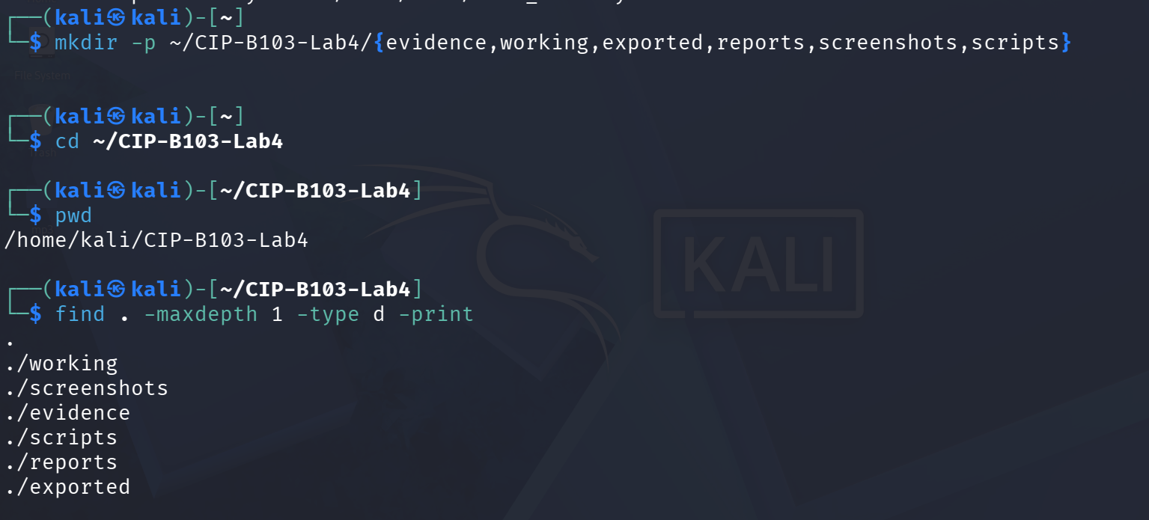
Screenshot 1: Evidence folder structure created (mkdir, cd, pwd, find).
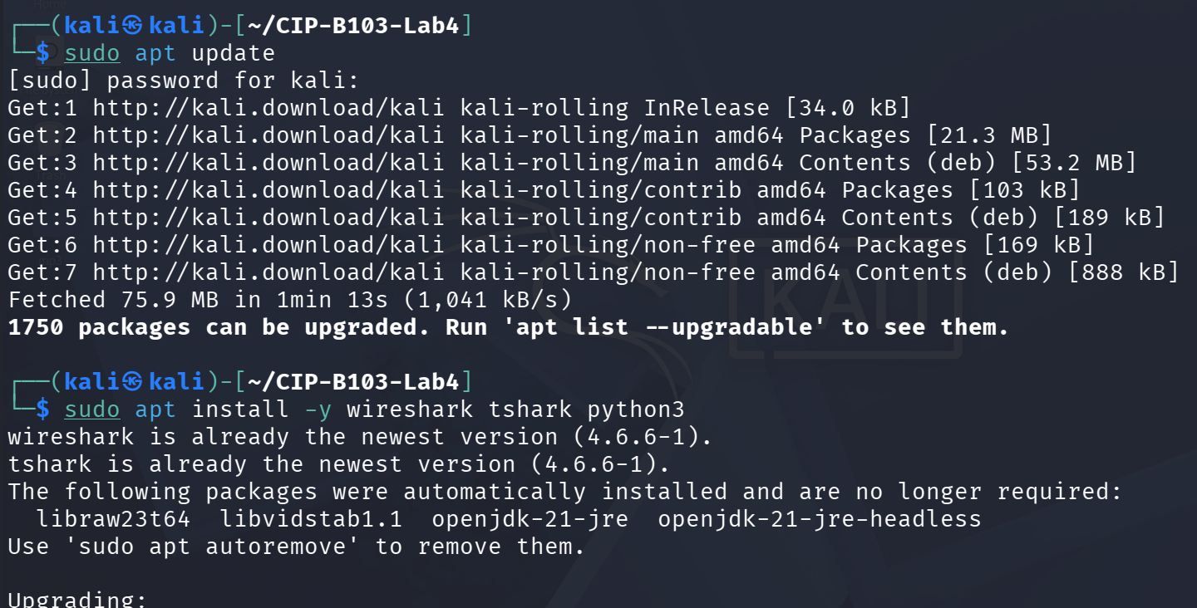
Screenshot 2: Package list updated and wireshark, tshark, python3 installed.
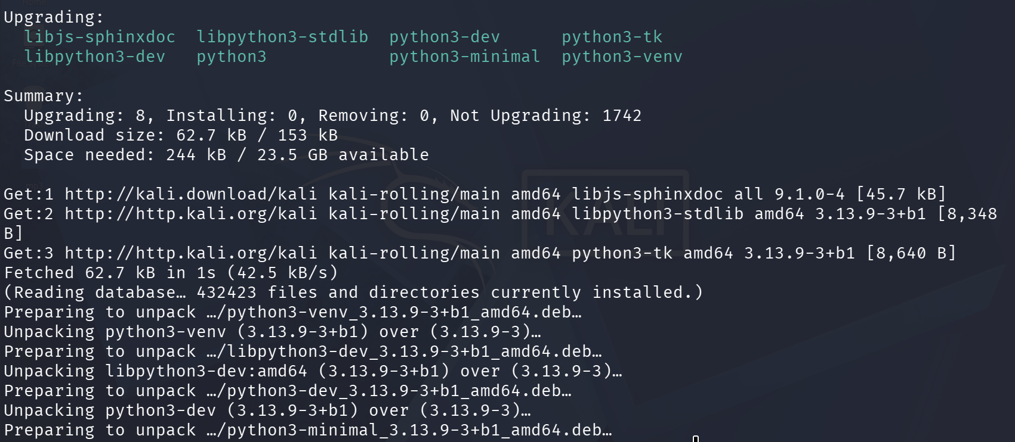
Screenshot 3: Package installation continued.
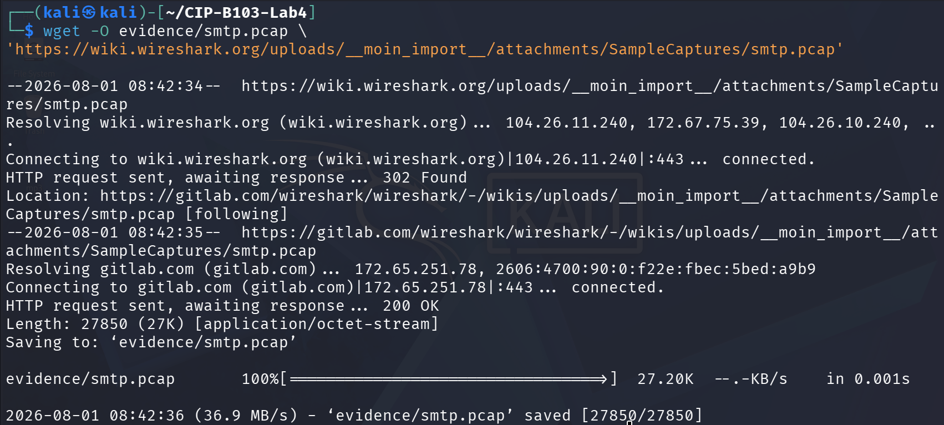
Screenshot 4: smtp.pcap downloaded via wget from the Wireshark wiki sample captures repository.
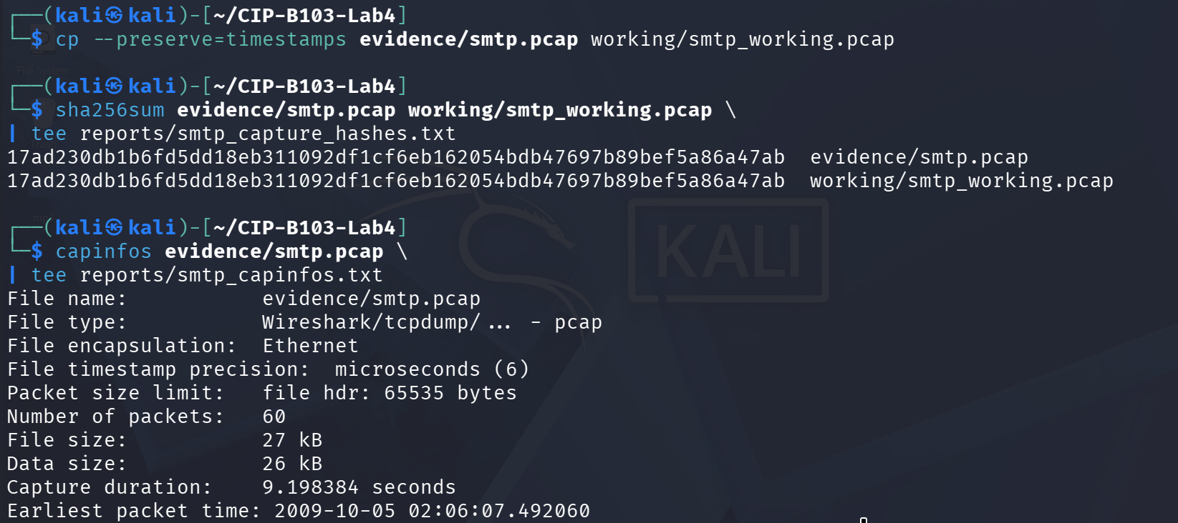
Screenshot 5: Working copy created, SHA-256 hashed, and capinfos summary started.
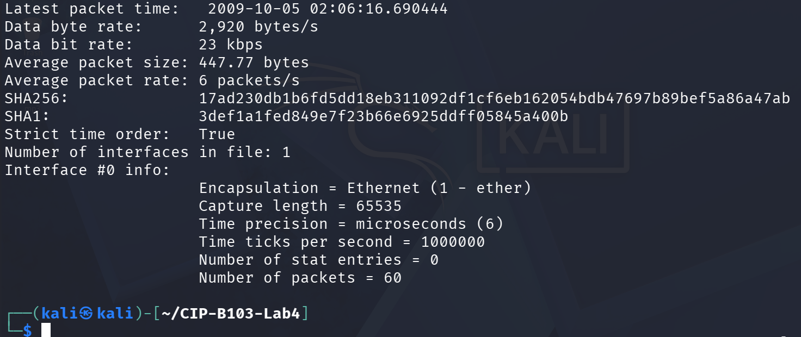
Screenshot 6: capinfos summary continued, including SHA256/SHA1 and interface details.

7. Mini Evidence and Chain-of-Custody Worksheet
Field | Student Entry
Case/lab identifier | CIP-B103-Lab4-Fuseini Imoru Kantuogaa
Trainee name | Fuseini Imoru Kantuogaa
Date and time started | 1 August 2026, approx. 08:42 local (Kali VM) timestamp of the wget download of the evidence file
Evidence file name(s) | smtp.pcap (working copy: smtp_working.pcap)
Source or generation method | Downloaded via wget from the official Wireshark wiki SampleCaptures repository a historical (2009) third-party training capture, not locally generated
Original SHA-256 | 17ad230db1b6fd5dd18eb311092df1cf6eb162054bdb47697b89bef5a86a47ab (evidence/smtp.pcap) confirmed by capinfos SHA256 output
Working-copy SHA-256 | 17ad230db1b6fd5dd18eb311092df1cf6eb162054bdb47697b89bef5a86a47ab (working/smtp_working.pcap) identical to original
Analysis workstation/VM | Kali Linux (user: kali), CIP-B103-Lab4 working directory
Notes on any changes | None. cp --preserve=timestamps used for the working copy; SHA-256 of evidence, working copy and the capinfos-reported hash all match, confirming no alteration.

8. Part A - Inventory the Capture and Locate SMTP Streams
tshark -r working/smtp_working.pcap -q -z conv,tcp | tee reports/tcp_conversations.txt
tshark -r working/smtp_working.pcap -Y 'smtp' -T fields \
-e frame.number -e frame.time -e ip.src -e tcp.srcport -e ip.dst -e tcp.dstport -e _ws.col.Info \
| tee reports/smtp_packet_inventory.tsv
Record the SMTP server port, client ephemeral port, first packet time, last packet time and number of SMTP frames.
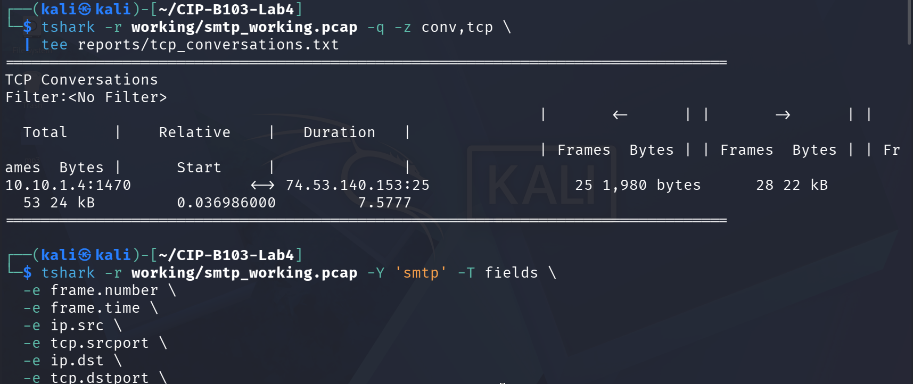
Screenshot 7: TCP conversation summary and start of the smtp packet-inventory filter.
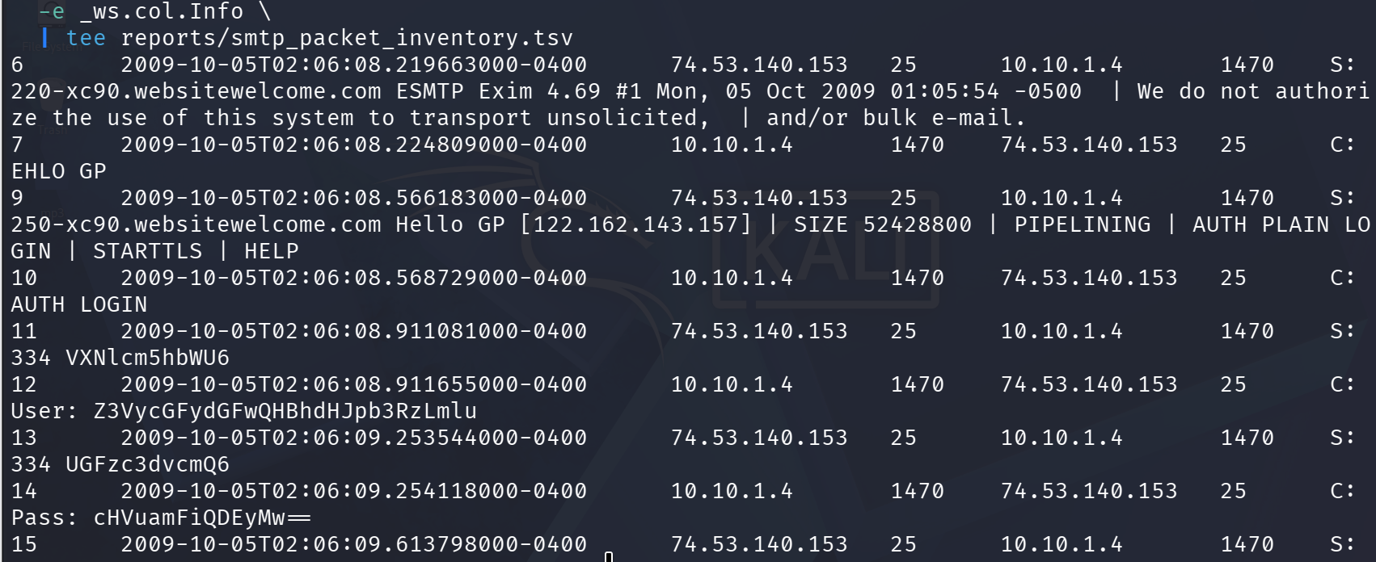
Screenshot 8: SMTP packet inventory — banner, EHLO, AUTH LOGIN and Base64 challenge/response.
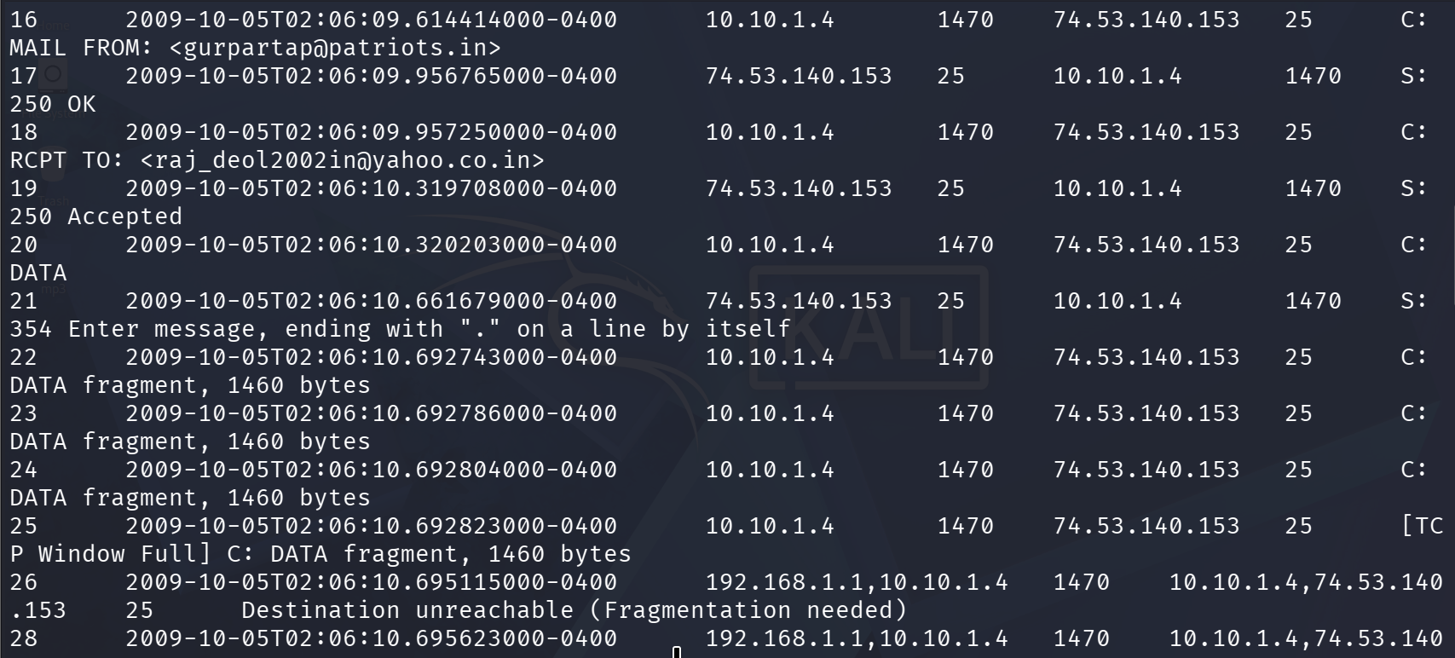
Screenshot 9: SMTP packet inventory continued — MAIL FROM, RCPT TO, DATA and message fragments.
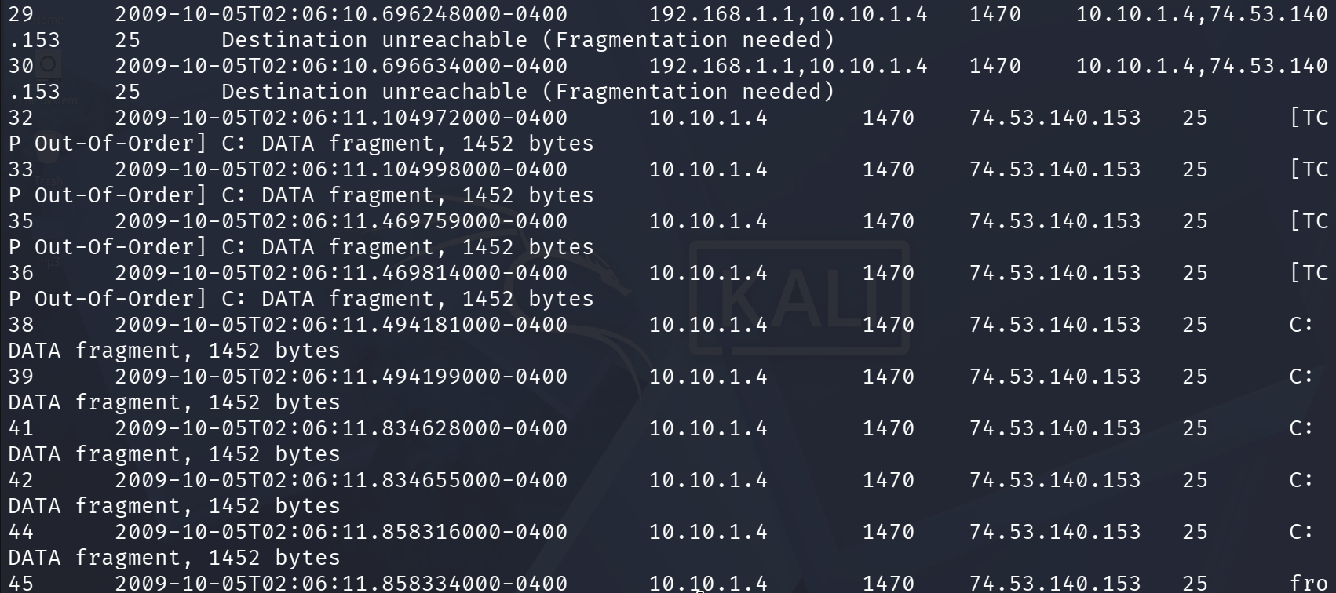
Screenshot 10: SMTP packet inventory continued — fragmented/out-of-order DATA segments.
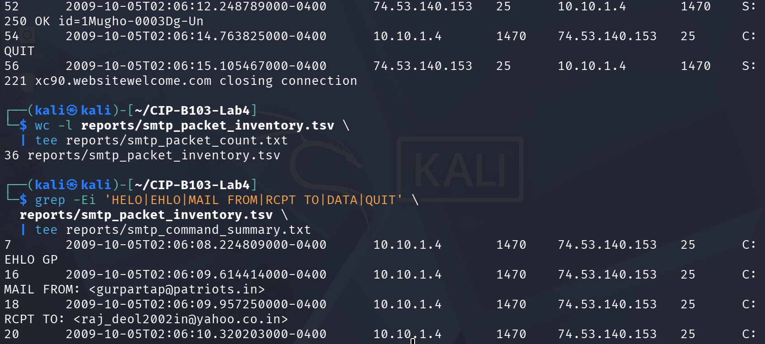
Screenshot 11: Final OK/QUIT/closing frames, inventory line count, and command-summary grep.
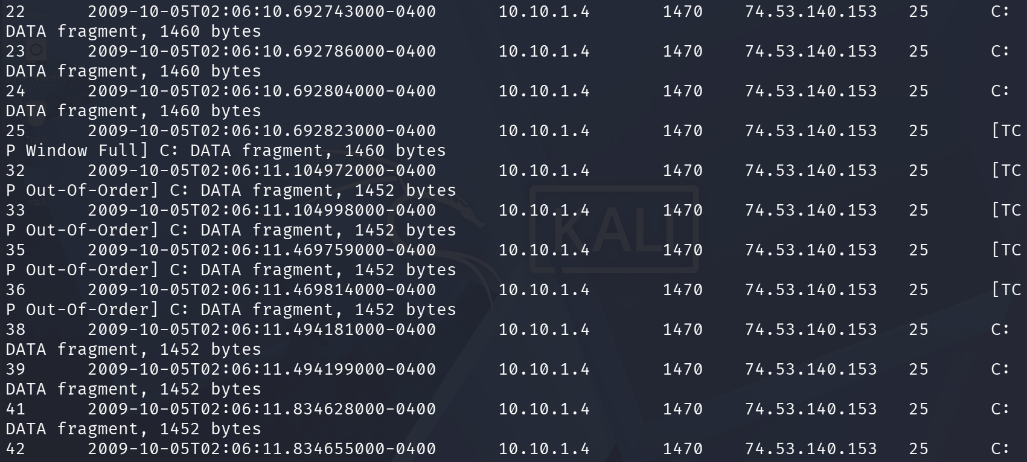
Screenshot 12: Command-summary grep continued (DATA fragments).

9. Part B - Identify Commands and Response Codes
Sequence | Direction | Command/Code | Meaning | Timestamp
1 | Server to client | 220 | Service ready | 2009-10-05 02:06:08.219663 -0400 (frame 6)
2 | Client to server | EHLO/HELO | Client greeting | 2009-10-05 02:06:08.224809 -0400 (frame 7, “EHLO GP”)
3 | Client to server | AUTH | Authentication method | 2009-10-05 02:06:08.568729 -0400 (frame 10, “AUTH LOGIN”)
4 | Client to server | MAIL FROM | Envelope sender | 2009-10-05 02:06:09.614414 -0400 (frame 16)
5 | Client to server | RCPT TO | Envelope recipient | 2009-10-05 02:06:09.957250 -0400 (frame 18)
6 | Client to server | DATA | Message content begins | 2009-10-05 02:06:10.320203 -0400 (frame 20)
7 | Client to server | QUIT | Session termination | 2009-10-05 02:06:14.763825 -0400 (frame 54)
tshark -r working/smtp_working.pcap -Y 'smtp.req || smtp.rsp' -T fields \
-e frame.number -e frame.time -e ip.src -e ip.dst -e smtp.req.command -e smtp.req.parameter \
-e smtp.response.code -e smtp.response.parameter \
| tee reports/smtp_commands_responses.tsv
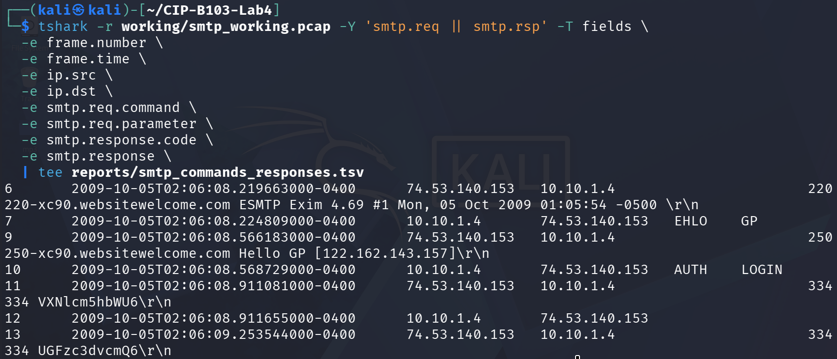
Screenshot 13: smtp.req/smtp.rsp field extraction — banner, EHLO, AUTH and Base64 challenge (start).
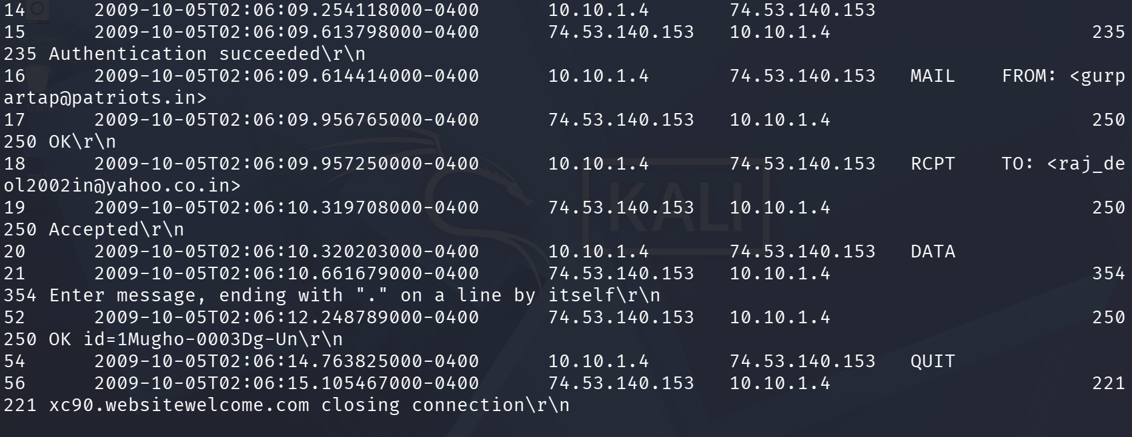
Screenshot 14: smtp.req/smtp.rsp continued — authentication success, MAIL FROM/RCPT TO/DATA, QUIT/closing.
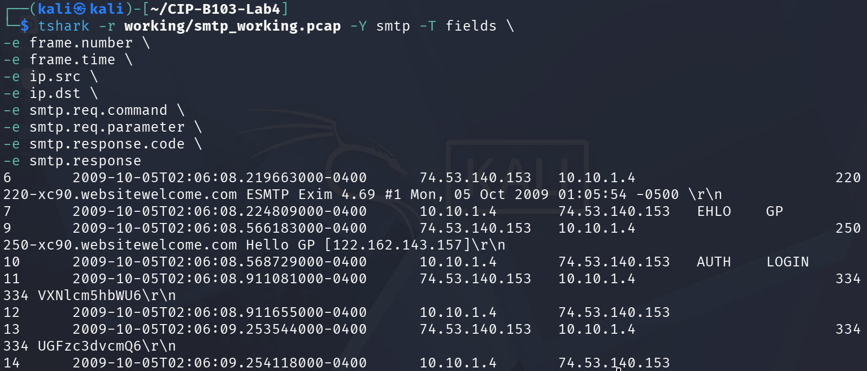
Screenshot 15: Repeat SMTP field extraction confirming the same command/response sequence (start).
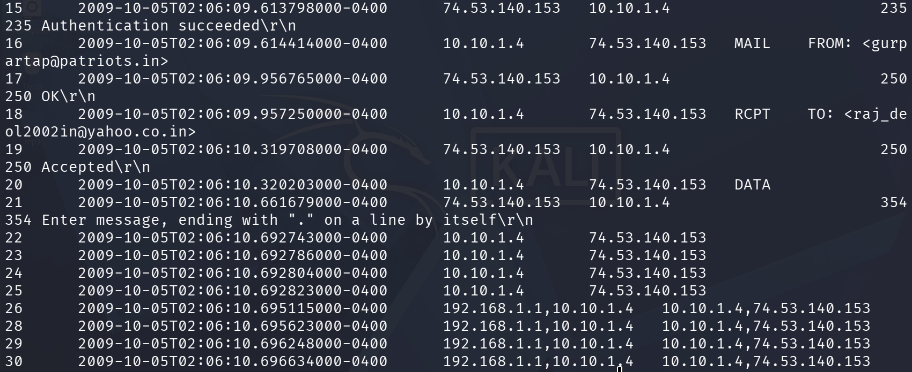
Screenshot 16: Repeat extraction continued — authentication success through DATA fragments.
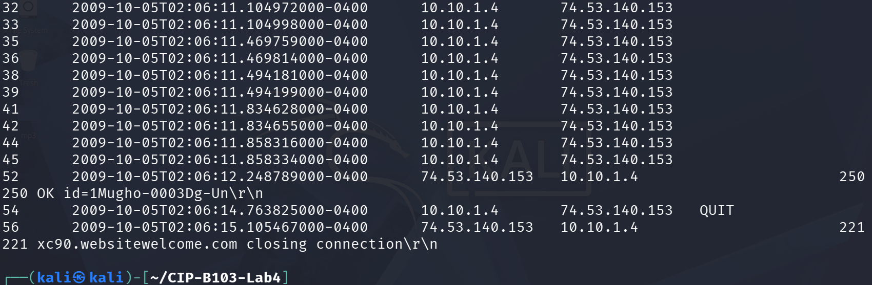
Screenshot 17: Repeat extraction concluded — final OK/QUIT/closing frames.

10. Part C - Decode Base64 Authentication Evidence
Base64 is encoding, not encryption. Copy only the required encoded values into the offline script. Do not use online decoders.
python3 - <<'PYLAB'
import base64
samples = {
'username': 'REPLACE_WITH_CAPTURED_BASE64',
'password': 'REPLACE_WITH_CAPTURED_BASE64'
}
for label, value in samples.items():
try:
decoded = base64.b64decode(value).decode('utf-8', errors='replace')
print(f'{label}: {decoded}')
except Exception as exc:
print(f'{label}: decode failed: {exc}')
PYLAB
Reporting Rule
In the public-facing report body, show a masked value such as analyst@example.com and P********3. Place full decoded values only in the protected evidence appendix if required by the instructor.
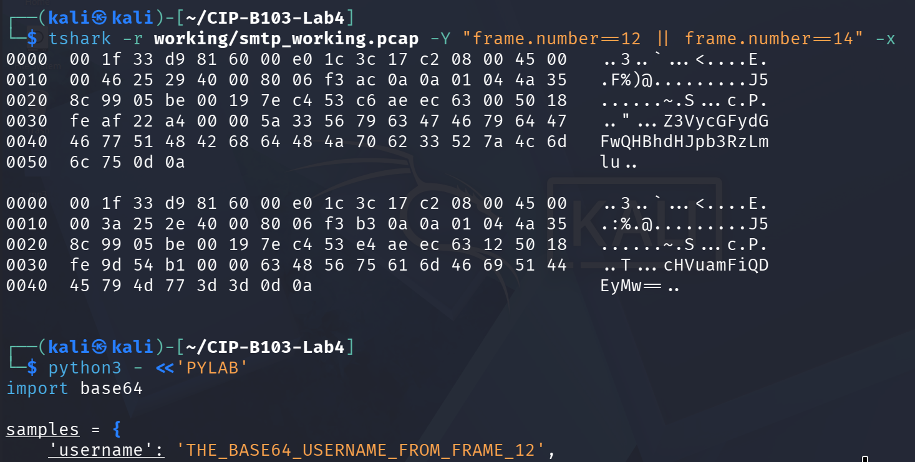
Screenshot 18: Hex dump of the Base64 username/password frames and start of the offline decode script.
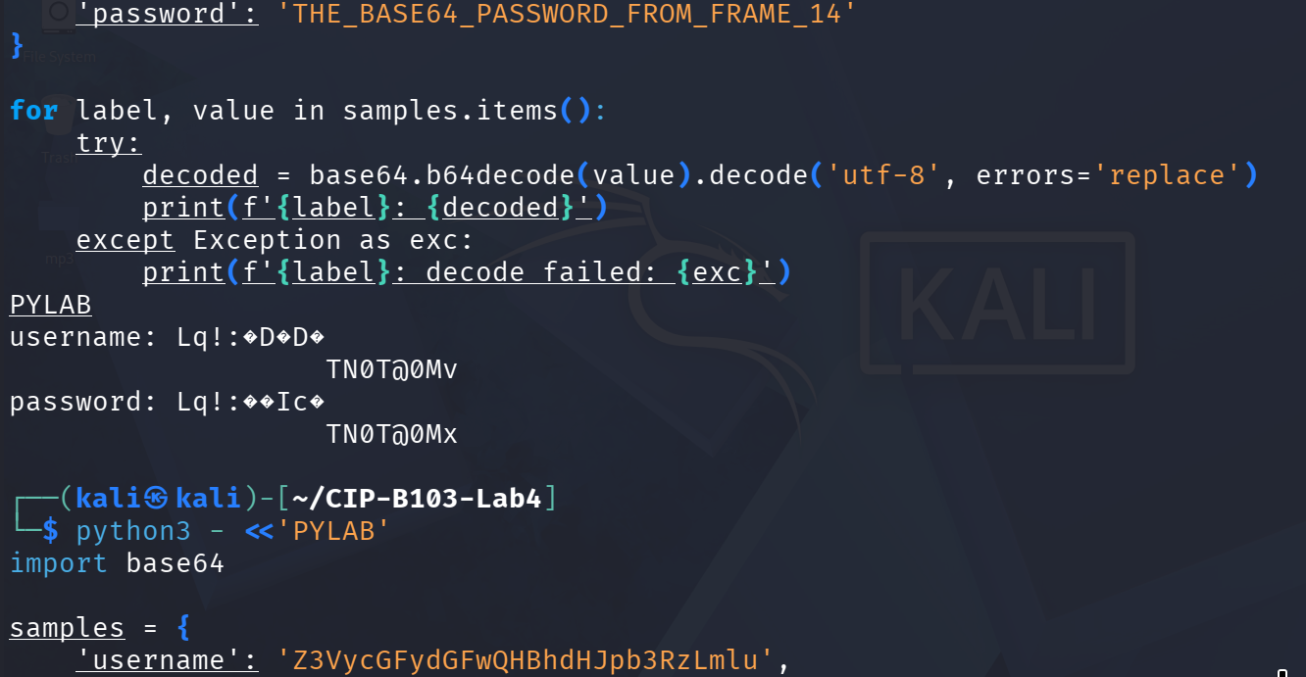
Screenshot 19: Decode script (placeholder run) and start of the corrected script with the captured Base64 values.
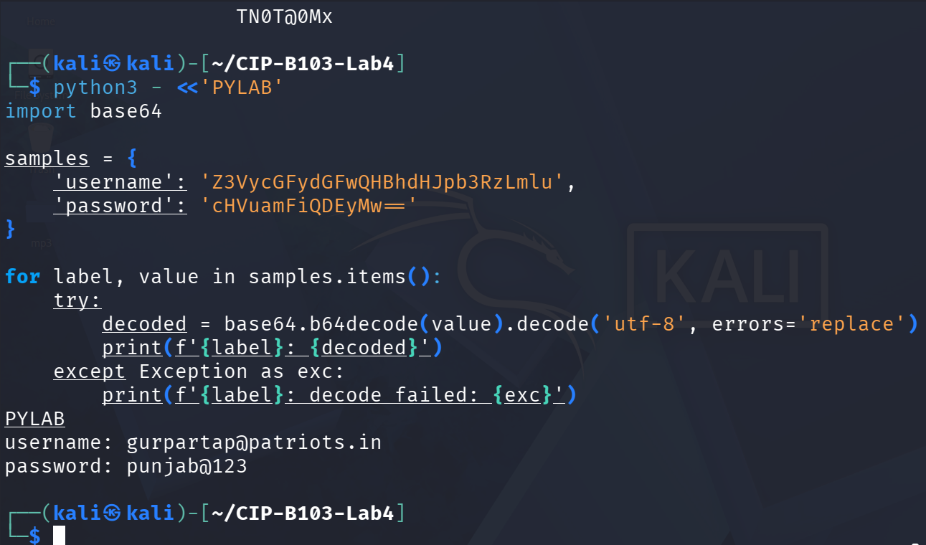
Screenshot 20: Corrected decode script executed, recovering the authentication username and password.

11. Part D - Reconstruct the Email Message
- In Wireshark select an SMTP packet and choose Follow > TCP Stream.
- Identify SMTP envelope fields separately from RFC message headers.
- Record Date, From, To, Subject, Message-ID, MIME-Version, Content-Type and User-Agent/X-Mailer where present.
- Determine whether the body is plain text, HTML, multipart or contains an attachment.
- Save a redacted text reconstruction to reports/reconstructed_email_redacted.txt.
# Replace STREAM with the relevant stream number
tshark -r working/smtp_working.pcap -q -z follow,tcp,ascii,STREAM \
| tee reports/smtp_stream_STREAM.txt
grep -Ei '^(Date|From|To|Subject|Message-ID|MIME-Version|Content-Type|User-Agent|X-Mailer):' \
reports/smtp_stream_STREAM.txt | tee reports/message_headers.txt
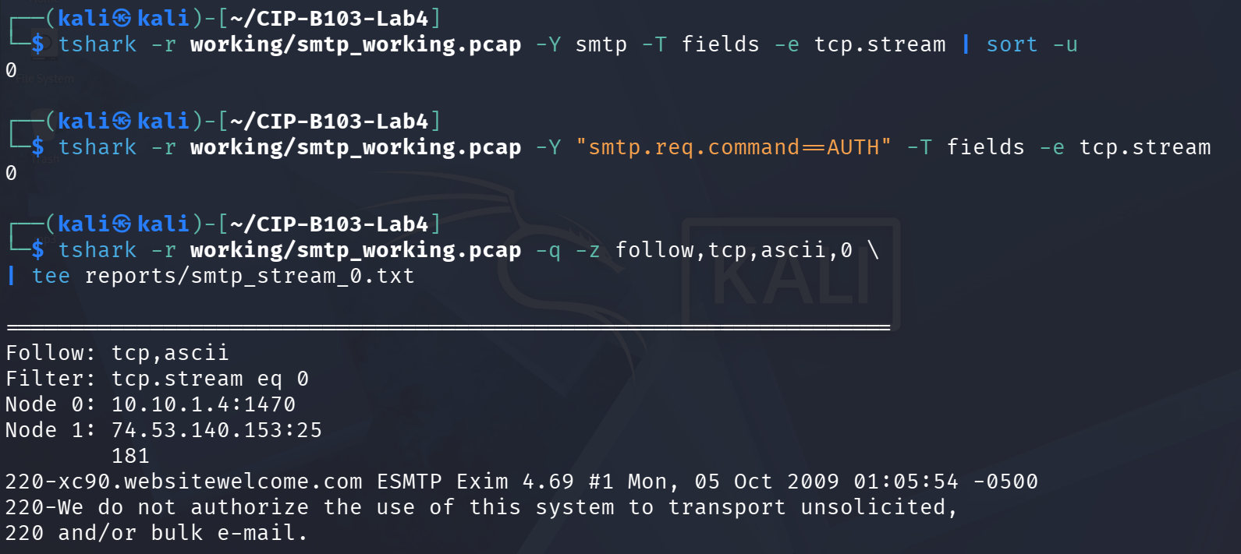
Screenshot 21: TCP stream/AUTH lookups and start of the Follow TCP Stream reconstruction (banner).
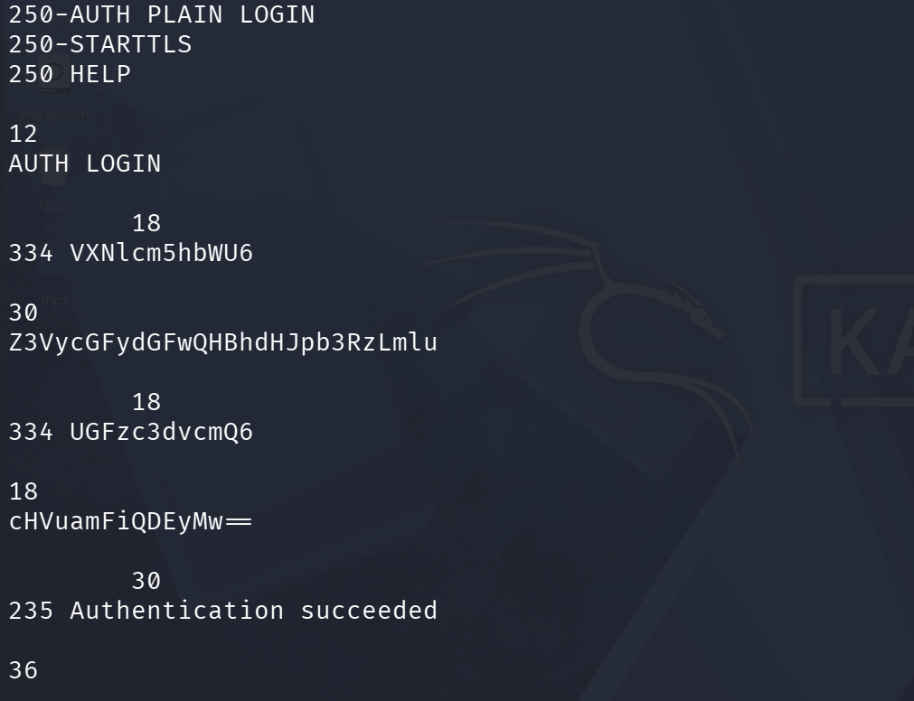
Screenshot 22: Follow TCP Stream continued — EHLO response and AUTH LOGIN exchange.
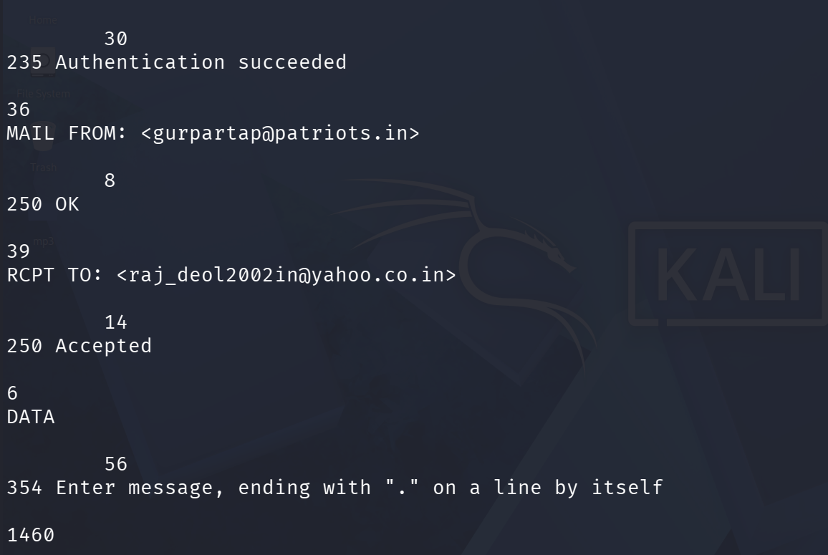
Screenshot 23: Follow TCP Stream continued — MAIL FROM, RCPT TO, DATA and start of message.
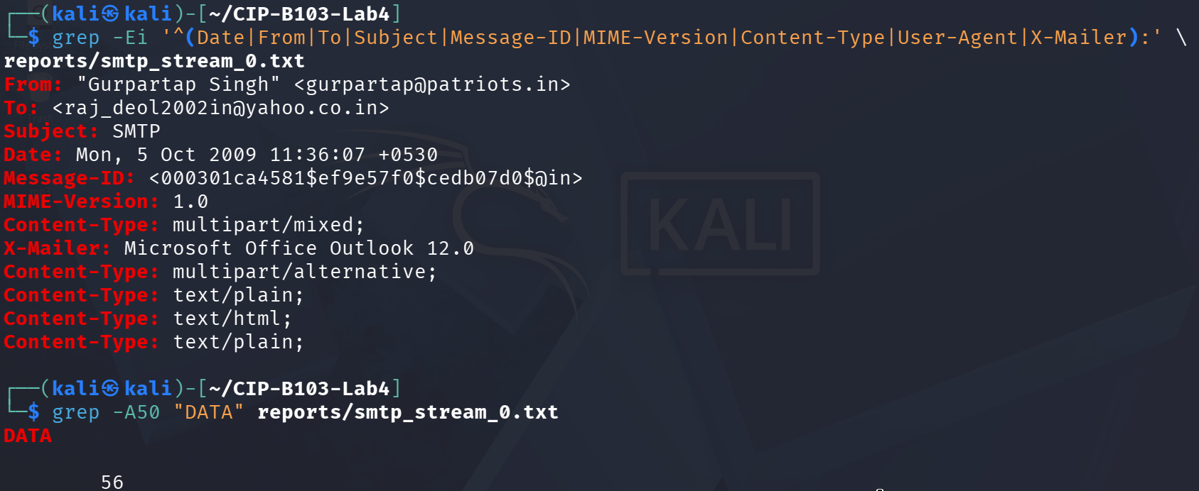
Screenshot 24: grep extraction of RFC message headers (From, To, Subject, Message-ID, etc.).
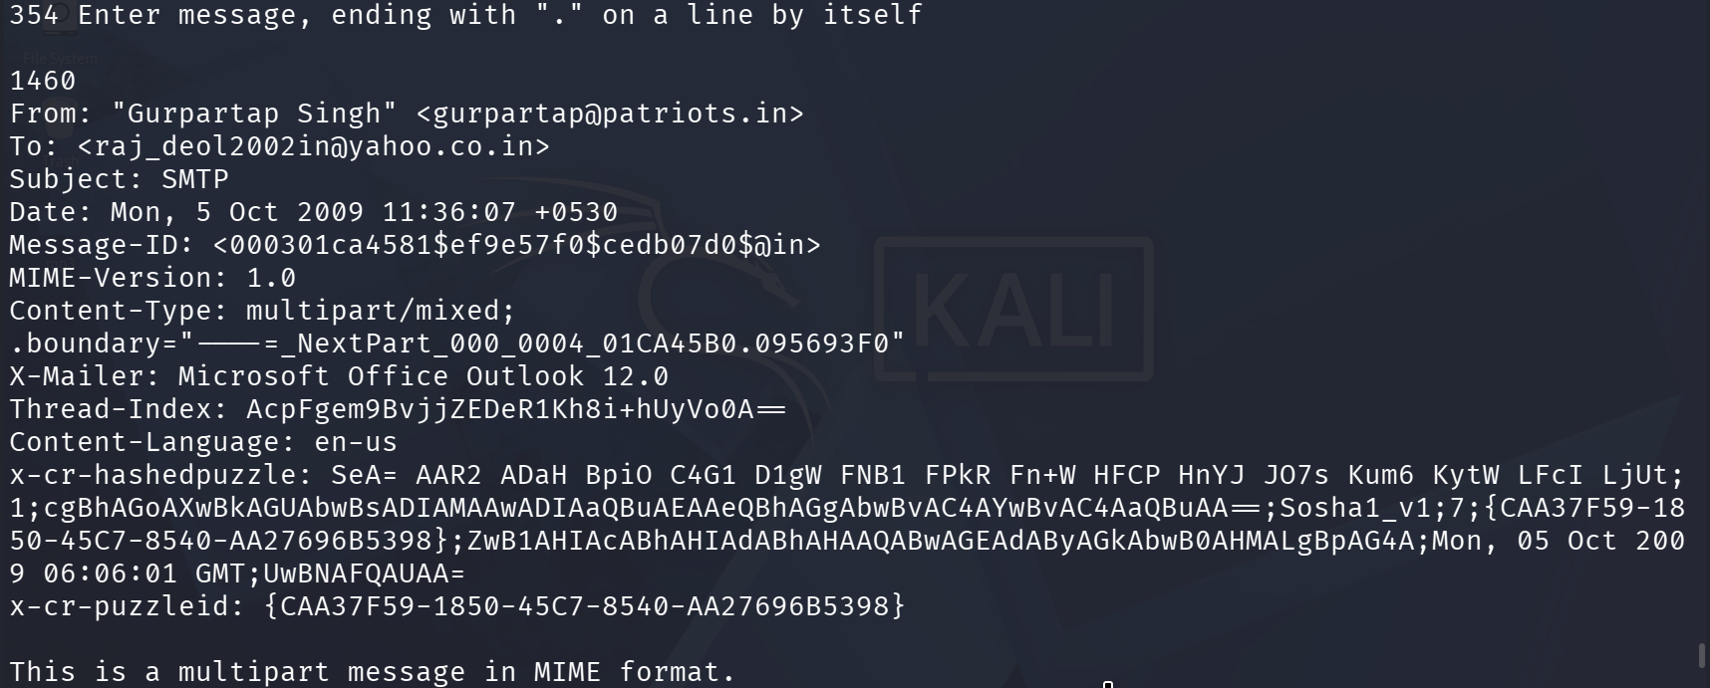
Screenshot 25: Full message header block recovered from the reconstructed stream.
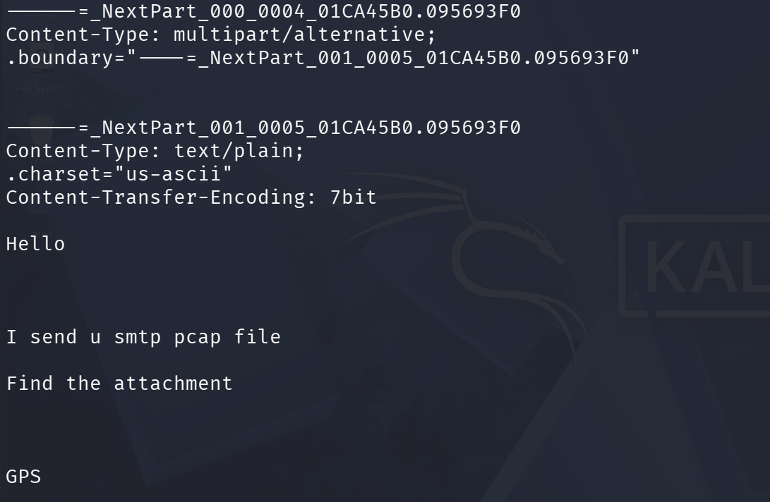
Screenshot 26: MIME boundary and the plain-text body part of the message.
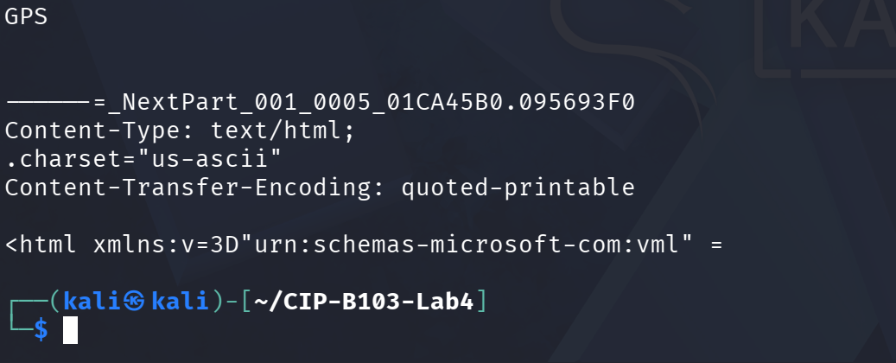
Screenshot 27: HTML body part of the multipart/alternative message.

12. Part E - Determine Client, Hosts and Network Metadata
tshark -r working/smtp_working.pcap -Y 'smtp' -T fields \
-e frame.number -e frame.time_epoch -e eth.src -e eth.dst -e ip.src -e tcp.srcport \
-e ip.dst -e tcp.dstport -e tcp.stream \
| tee reports/smtp_network_metadata.tsv
tshark -r working/smtp_working.pcap -Y 'smtp contains "User-Agent" || smtp contains "X-Mailer"' \
-T fields -e frame.number -e tcp.stream -e smtp.req.parameter -e data-text-lines \
| tee reports/client_indicators.tsv
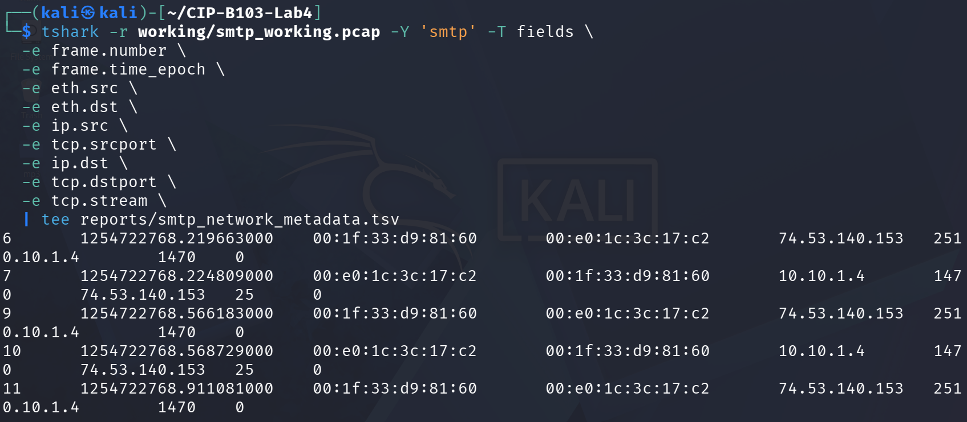
Screenshot 28: Network-metadata field extraction — frame time, MAC and IP/port pairs (start).
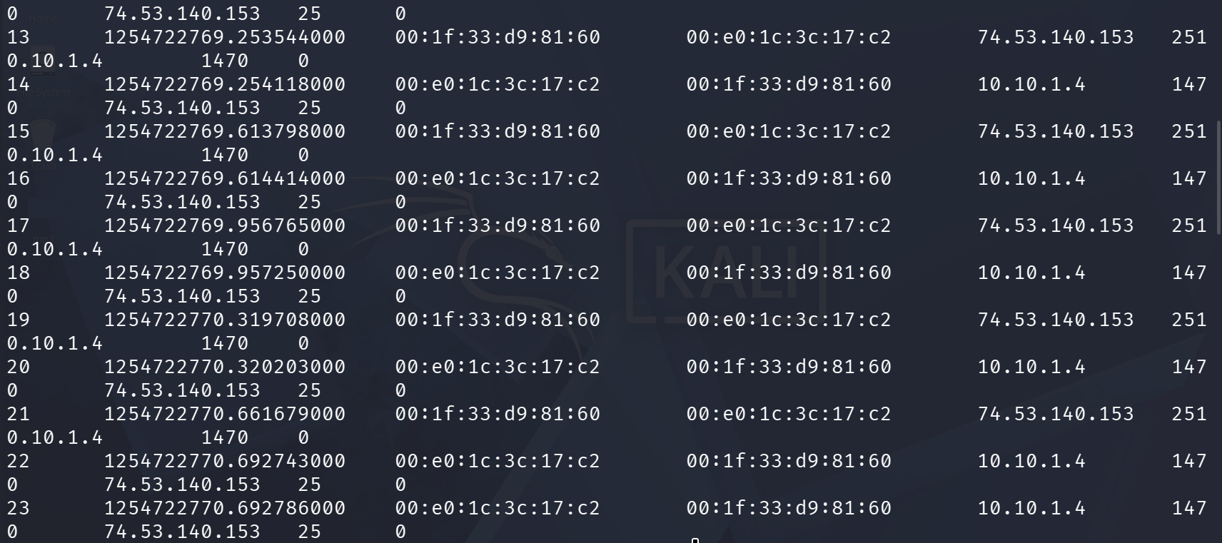
Screenshot 29: Network-metadata extraction continued.
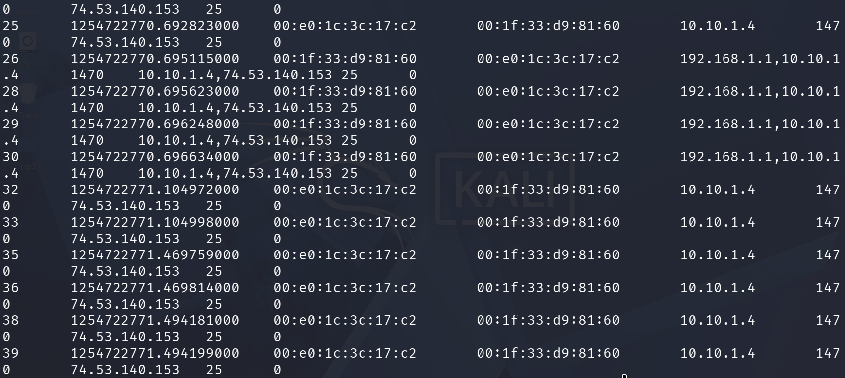
Screenshot 30: Network-metadata extraction continued, including the fragmentation-related frames.
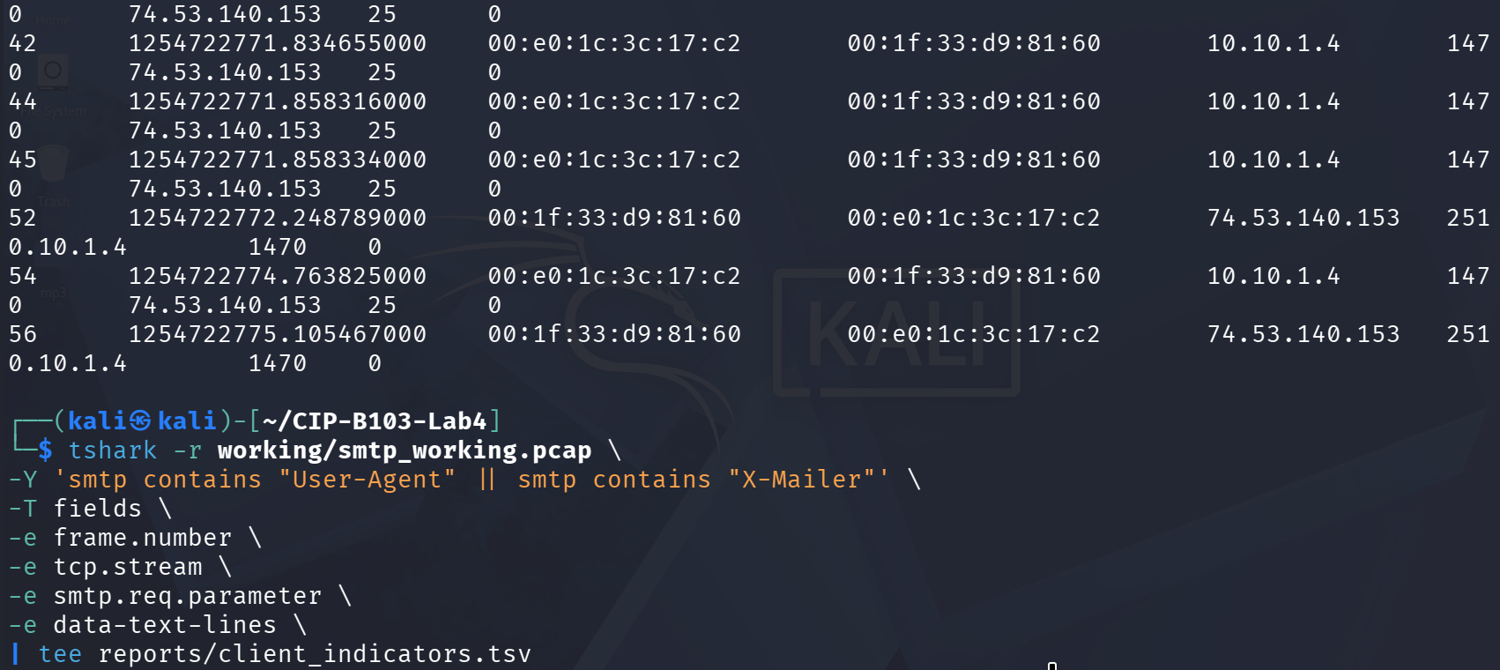
Screenshot 31: Network-metadata extraction concluded and start of the client-indicators filter.

13. Part F - Encryption and Evidential Limitations
- Check whether STARTTLS is requested and whether subsequent payload becomes TLS.
- If traffic is encrypted, document metadata that remains visible: endpoints, ports, timing, certificate/session information and byte counts.
- Do not claim message content or credentials when the capture does not reveal them.
- Explain that port number alone does not prove encryption; protocol negotiation and packet dissection must be examined.
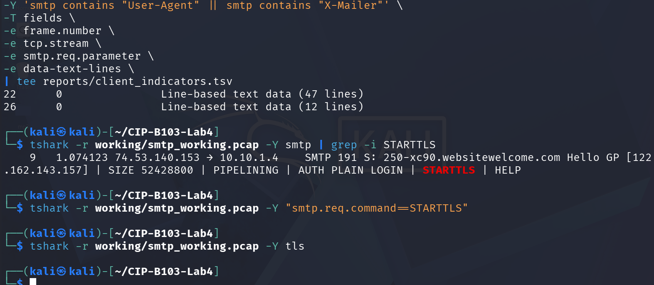
Screenshot 32: Client-indicator results, plus STARTTLS and TLS filter checks confirming plaintext delivery.

14. Required Findings Worksheet
Question | Finding
When did the SMTP session start and end? | SMTP dialogue ran 2009-10-05 02:06:08.219663 -0400 (220 banner, frame 6) to 02:06:15.105467 -0400 (221 closing, frame 56); the overall capture spans 02:06:07.492060 to 02:06:16.690444 (9.198384 s, per capinfos).
Client IP/MAC and port | 10.10.1.4, MAC 00:1f:33:d9:81:60, port 1470
Server IP/MAC and port | 74.53.140.153, MAC 00:e0:1c:3c:17:c2, port 25
SMTP server banner | 220-xc90.websitewelcome.com ESMTP Exim 4.69 #1 Mon, 05 Oct 2009 01:05:54 -0500 (frame 6)
Client software | Microsoft Office Outlook 12.0 (X-Mailer header in the reconstructed message)
Authentication method | AUTH LOGIN with Base64-encoded username/password (frames 10–15); server responded 235 Authentication succeeded. Decoded offline per Part C — masked here per the lab’s reporting rule: username gu*******@patriots.in, password pu*******3 (full values recorded only in the protected reports/ output).
Envelope sender and recipient | MAIL FROM: <gu*******@patriots.in> (frame 16); RCPT TO: <ra************@yahoo.co.in> (frame 18) — masked per the reporting rule
Message From/To/Subject | From: “Gurpartap Singh” <gu*******@patriots.in>; To: <ra************@yahoo.co.in>; Subject: SMTP (Date header: Mon, 5 Oct 2009 11:36:07 +0530)
Message body type | multipart/mixed containing a multipart/alternative part with both text/plain and text/html versions of the same short note (Content-Type headers in the reconstructed stream)
Attachment present? | No distinct attachment MIME part was found in the reconstructed headers/body captured; the multipart/mixed wrapper is consistent with Outlook’s default structure rather than a confirmed file attachment, though the body text itself references “Find the attachment.”
STARTTLS/TLS observed? | STARTTLS was advertised in the EHLO response (250-STARTTLS) but never invoked by the client; filters for smtp.req.command==STARTTLS and tls returned no matching frames — the entire session, including credentials, ran in plaintext
Key limitations | Single historical capture with no surrounding context; several mid-stream frames show IP fragmentation, out-of-order segments and ICMP “destination unreachable (fragmentation needed)” messages that required careful reassembly; findings are limited to what tshark’s SMTP/data dissectors could parse from this one file, and no attachment content itself was recovered.

Required Screenshots Checklist
☐ Capture hashes and capinfos summary.
☐ SMTP conversation list.
☐ 220 service-ready response.
☐ EHLO/HELO and AUTH exchange.
☐ Masked Base64 decoding result.
☐ MAIL FROM, RCPT TO and DATA.
☐ Follow TCP Stream reconstruction.
☐ Email headers and client software.
☐ Source/destination IP, ports and MAC addresses.
☐ TLS/STARTTLS assessment.

Student Report Template
- Executive summary.
- Evidence integrity and scope.
- SMTP timeline.
- Command/response analysis.
- Authentication evidence and redaction method.
- Email reconstruction.
- Client/server and network metadata.
- Encryption assessment and limitations.
- Conclusions and appendix.

Submission Requirements
- One PDF report named CIP-B103-Lab4_RegNo_FullName.pdf.
- The original or generated PCAP/PCAPNG evidence file and its SHA-256 hash text file.
- A reports folder containing exported CSV/TXT command output and any recovered objects.
- Screenshots must be readable, numbered and referenced in the report narrative.
- Compress the report and evidence outputs into one ZIP named with your registration number and lab number.
- Do not submit passwords or decoded credentials in public discussion channels; include them only in the protected assessment submission where required.

Marking Rubric (100 Marks)
Assessment Area | Marks | What the Instructor Will Check
Evidence handling | 10 | Original preserved, working copy and hashes documented.
SMTP command analysis | 20 | Correct commands, codes, direction and timeline.
Authentication analysis | 15 | Correct offline decoding and safe redaction.
Message reconstruction | 25 | Accurate headers, body type, client and content findings.
Network metadata and encryption | 20 | Correct endpoints, ports, MACs and TLS assessment.
Report quality | 10 | Professional, concise and evidence-linked report.

Instructor Quick Answer Guide
Checkpoint | Expected Observation
Service-ready code | 220.
Client greeting | HELO or EHLO.
Authentication evidence | Often AUTH LOGIN with Base64-encoded fields in plaintext SMTP.
Message data | Begins after DATA and ends with SMTP termination sequence.
Client indicator | Slide capture identifies Microsoft Outlook 12.0.
Important limitation | Base64 is reversible encoding; TLS would hide application content.

Command Reference Summary
Command | Purpose
smtp | Wireshark display filter for SMTP.
smtp.req / smtp.rsp | Filter SMTP requests and responses.
Follow TCP Stream | Reconstruct the application conversation.
base64.b64decode | Decode Base64 offline.
capinfos file | Summarize capture metadata.
eth.addr / ip.addr / tcp.port | Endpoint filters.

Academic Integrity and Authorization Statement
Student Declaration
I confirm that I completed this lab in an authorized environment, preserved the supplied evidence, did not target any third-party system, and accurately documented my own commands, observations and conclusions.

